Guide to Service Agreements

Instructions for participants and service providers

 | This information is written in an easy to read way. We use pictures to explain some ideas.
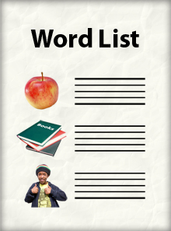 | Some words are written in bold. We explain what these words mean. There is a list of these words on page 29.
 | You can ask for help to read this Guide to Service Agreements. A friend, family member or support person may be able to help you.

What is in the Guide to Service Agreements?
What is a Service Agreement? 3
What is this Guide to Service Agreements about? 4
Who can make a Service Agreement? 6
How is a Service Agreement different to an NDIS Plan? 7
What should be included in a Service Agreement? 9
What is expected of you? 11
What is expected of the service provider? 13
How to pay for your supports 16
How to change a Service Agreement 18
How to end a Service Agreement 19
What to do if you have a problem 21
Sample Service Agreement 22
Additional information for service providers 27
Checklist for Service Agreements 28
Word list 29
Where can I get more information? 30

What is a Service Agreement?
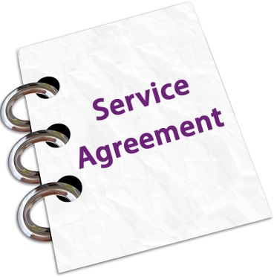 | A Service Agreement is a document.
It is for you and your service provider.
The service provider is the person or organisation that provides you with supports.
 | The document says that you both agree about the services you are going to receive.
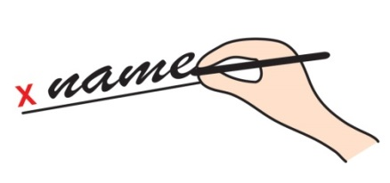 | When you have agreed, you both sign the document.

What is this Guide to Service Agreements about?
We've written this Guide for you.
You are a person who is using the NDIS.
We call people who are using the NDIS 'participants'.
 | We've also written this guide for service providers – the people who are offering services to you.
 | That way, the service providers also know what needs to be included in a Service Agreement.
 | And they can help you prepare a Service Agreement if that's what you need.
 | There is additional information for service providers on page 27.
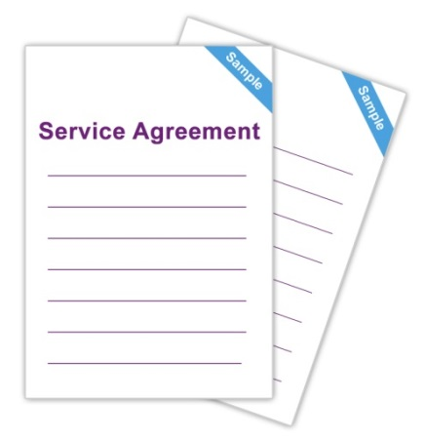 | You will find a sample Service Agreement on page 22.
 | There is a useful checklist to make sure you've done everything you need to do when making a Service Agreement. You'll find this checklist on page 28.
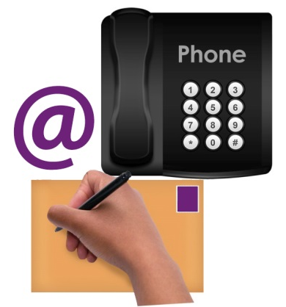 | If you would like any more information about Service Agreements, you can contact us.  Our contact details are on page 30.
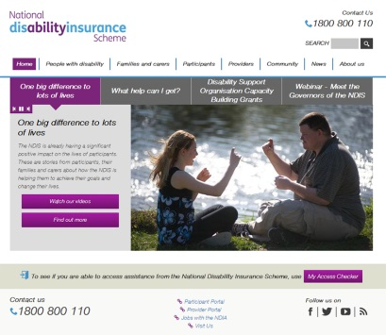 | There are also a range of useful tools from the Practical Design Fund to help you with Agreements.  These are available on our website at  www.ndis.gov.au/people-disability/practical-design-fund

Who can make a Service Agreement?
 | A Service Agreement can be made by a participant of the NDIS and their service provider.
Sometimes, you might ask another trusted person to enter into the Agreement for you.
This might be a family member, carer, friend or other person.
 | A service provider might be:
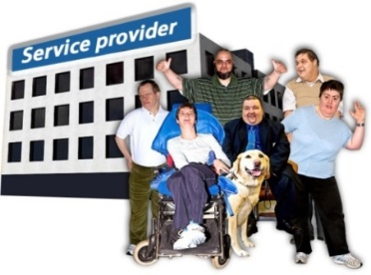 | - An organisation that offers disability support.
 | - A community organisation.
 | - A mainstream service provider, such as a business that provides cleaning, health or gardening services.

How is a Service Agreement different to an NDIS Plan?
 | Your NDIS Plan explains what you want to do and what your goals are.
 | And it explains the support you will need to achieve your goals.
 | The Service Agreement is different.
 | The Service Agreement is about the working relationship you have with your service provider.
 | It makes sure that you and your service provider both agree about the supports you will receive and how these supports will be provided.
 | One of the big ideas behind the NDIS is that you have choice and control about the support that you use.
 | You get to choose who provides your supports. And you get to choose how you receive supports.
 | The Service Agreement is a good way to make sure you receive the services that are right for you.
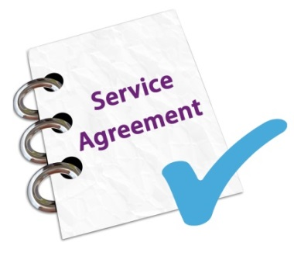 | And having a Service Agreement is a helpful way to make sure you have everything in writing if any problems occur.
 | Don't forget to keep a copy of your Service Agreement in a safe place.
 | Also, it's a good idea to take a copy of your NDIS Plan to any meetings you have about your Service Agreement.
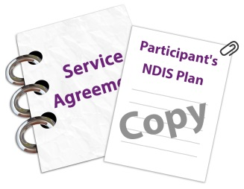 | If you want to, you can attach a copy of your NDIS Plan to the Agreement.

What should be included in a Service Agreement?
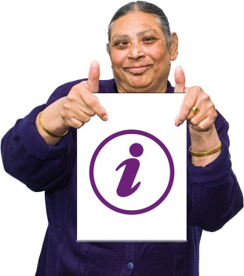 | The Service Agreement should include information about the supports you receive.
 | It doesn't have to be complicated. It can be quite simple. It needs to say:
 | - What supports you will receive.
 | - When, where and how you will receive those supports.
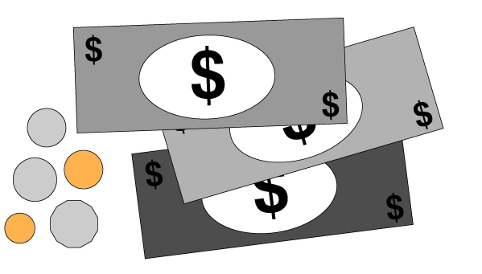 | - How much the supports will cost and how they will be paid for.
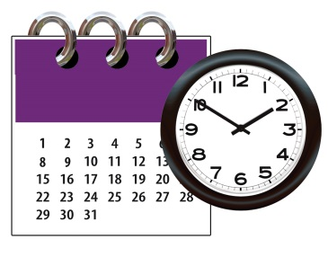 | - How long you need the supports for.
 | - What is expected of you. This is about your responsibilities. We explain this in more detail on page 11.
 | - What is expected of your service provider. We explain this in more detail on page 13.
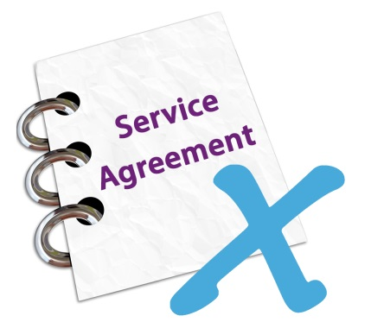 | - How you can end or change the Agreement.
 | - What you can do if any problems occur.

What is expected of you?
When you sign the Service Agreement, it means that you agree to do the things that are expected of you.
These are called your responsibilities.
 | Your responsibilities include things like:
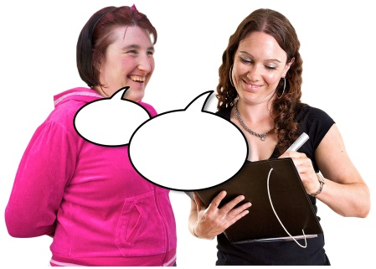 | - Telling the service provider about the supports that you want, and how you want to receive them.
 | - Being polite and respectful to the staff who work with you.
 | - Telling the service provider if you've got any problems.
 | - Telling the service provider if you can't make it to an appointment – you should always give them at least 24 hours' notice.
 | - Telling the service provider straight away if you want to end the Agreement.
 | - Letting the service provider know if your NDIS Plan changes or if you stop using the NDIS.
Every Service Agreement is unique.
The list above explains what we suggest you include.
This means that your Service Agreement may not have all of the things listed above in it, or it may have some other things in it.
This will depend on what you and your service provider agree.

What is expected of the service provider?
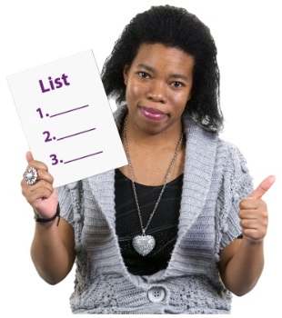 | Service providers have responsibilities too.  Below is a list of our suggestions of what these should be.  You and the service provider may agree on other things to include on the list.
 | The service provider's responsibilities include:
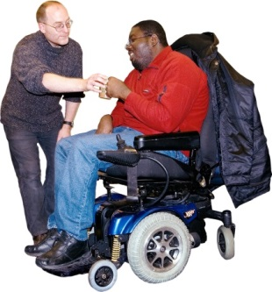 | - Providing the services that you have asked for.
 | - Being open and honest about the work that they do.
 | - Explaining things clearly.
 | - Treating you politely and with respect.
 | - Including you in all decisions about your supports.
 | - Letting you know what to do if you have a problem or want to complain.
 | - Listening to your feedback and fixing any problems quickly.
 | - Telling you if they want to end the Agreement.
 | - Making sure your information is correct and up to date.
 | - Storing your information carefully and making sure it is kept private.
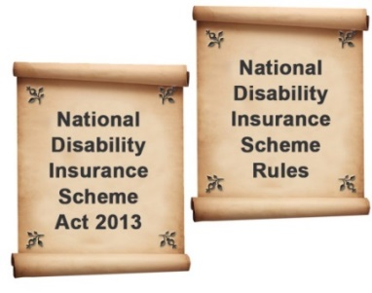 | - Obeying all the rules and laws that apply. This includes the National Disability Insurance Scheme Act 2013 and the National Disability Insurance Scheme Rules.
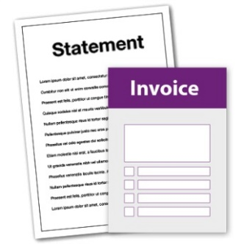 | - Providing invoices and statements for your supports.
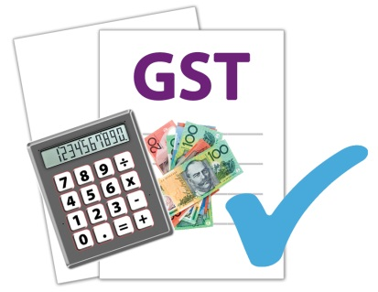 | - Checking whether GST applies.  There is more information about this on page 27.
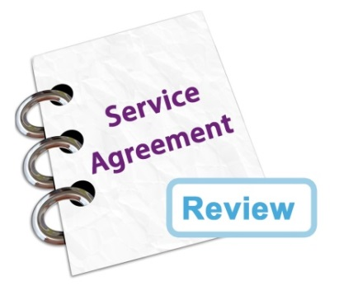 | - Checking that the Agreement is working well. You and the service provider will agree about how often the Agreement will be reviewed.

How to pay for your supports
 | There are different ways to pay for your supports.
 | Some people manage all of their NDIS funding themselves.
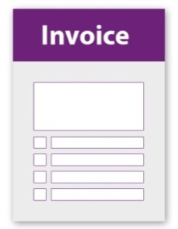 | In this case, you pay the invoices from the service provider directly. An invoice is like a bill.
 | Some people have a Plan Nominee to help them. This is a person you trust, like a family member or friend. If the NDIA says it’s ok, this person can manage your NDIS funding for you.
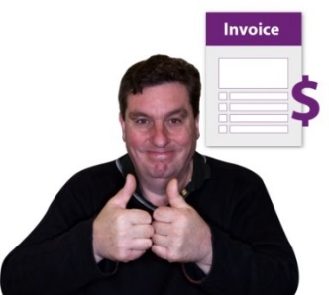 | In this case, the Plan Nominee pays the invoices from the service provider.
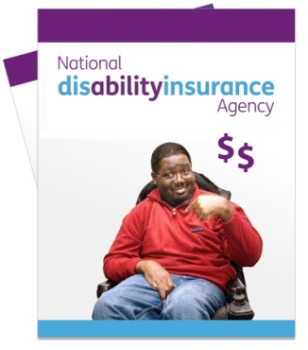 | Some people ask the National Disability Insurance Agency (NDIA) to manage the funding for them.
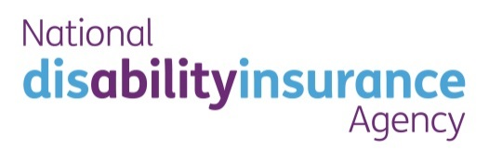 | In this case, the NDIA pays the invoices.
 | Some people use a Plan Management Provider. This is a person or organisation who helps to manage their funding.
 | In this case, the Plan Management Provider pays the invoices.
 | In all of these cases, the way the invoice is to be paid – such as via electronic transfer, cash or cheque – will be written in the Agreement.
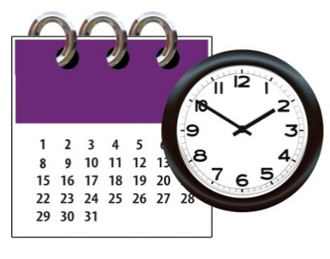 | And the time allowed to pay the invoice will be included as well. This might be 7 days, 14 days or more.

How to change a Service Agreement
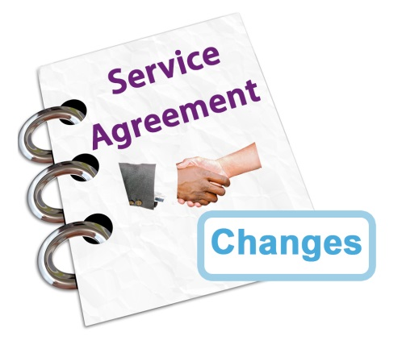 | You and the service provider will need to agree about how changes can be made to the Service Agreement.
 | Most Service Agreements will say:
 | - That the changes need to be in writing.
 | - That the participant and the service provider agree on the changes.
 | You may need to sign a new document saying that you agree with the changes.

How to end a Service Agreement
 | If you want to end the Service Agreement, you must tell the service provider.
 | You must let them know before you want the Agreement to end.
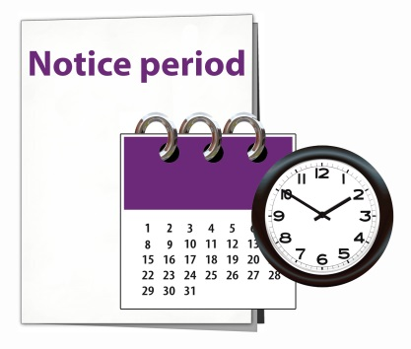 | Usually, in the Agreement, it will say how much time you must give them before the Agreement can end.  This is called a notice period.
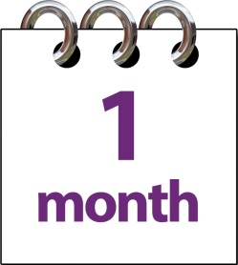 | This may be 1 month or more.
 | If the service provider wants to end the Agreement, they must tell you – and give you notice too.
 | Sometimes, an Agreement can end without a notice period. This could only happen if you or the service provider broke the Agreement in some way.
 | Let's look at an example.
 | Angus was upset because his support workers never turned up on time.
 | He made several complaints to his service provider.
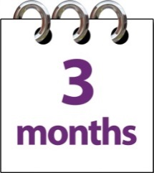 | But the service provider didn't do anything to fix the problem for more than 3 months.
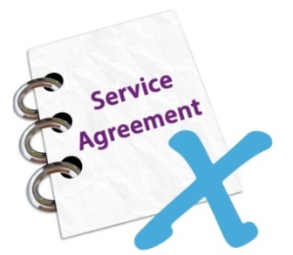 | Angus decided to end the Agreement and find another service provider.
 | He contacted the NDIA for more information.

Don't forget – you have responsibilities too!
You have responsibilities to the service provider too. If you don't do what's expected of you, the service provider can end the Agreement.

What to do if you have a problem
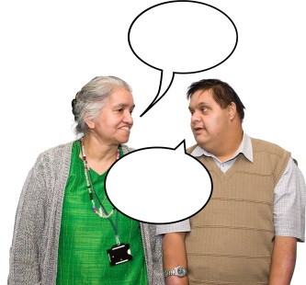 | The Service Agreement should explain who you can talk to if you have a problem.
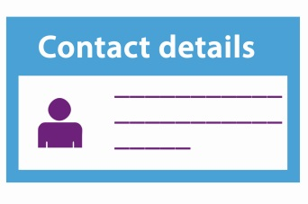 | It should give you the name of a person to talk to, and their contact details.
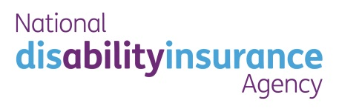 | If you don't want to talk to this person, or if your problem is not being fixed, you can contact the NDIA.
 | We can give you information about what you can do.
 | Our phone number is 1800 800 110.
 | You can visit one of our offices.
 | Or you can visit our website at www.ndis.gov.au

Sample Service Agreement

Who is making this Agreement?
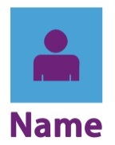 | The name of the participant or their trusted person:
 | The name of the service provider:

How does this Agreement fit in with the NDIS?
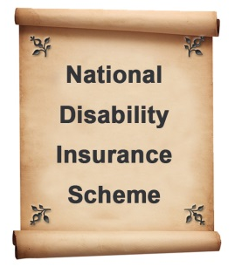 | This Agreement is made according to the rules and the goals of the National Disability Insurance Scheme (NDIS).
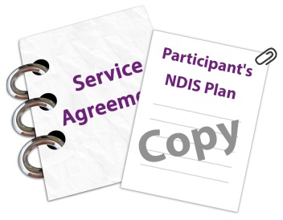 | A copy of the participant's NDIS Plan is attached to this Agreement.  Note: you don't have to include your NDIS Plan if you don't want to.
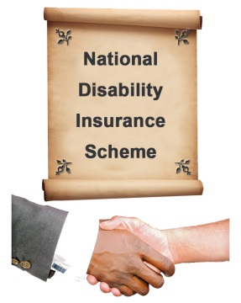 | The participant and the service provider agree that this Agreement is in line with the main ideas of the NDIS. These ideas include things like having more choices, achieving your goals and taking part in the community.

What supports will be provided?
What are the supports to be provided? List the following:
- how they will be provided
- when they will be provided
- who will provide them
- how long they will be provided for
- how much they will cost.

What is expected of the participant?
This section explains your responsibilities. | There's more information about this on page 11.

What is expected of the service provider?
This section explains the service provider's responsibilities. | There's more information about this on page 13.

How will payments be made?
This section explains who will pay the invoices, and how they will be paid. | There's more information about this on page 16.

How to make changes
This section explains how you or the service provider can make changes to the Agreement. | There's more information about this on page 18.

How to end the Agreement
This section explains how you or the service provider can end the Agreement. | There's more information about this on page 19.

What to do if there is a problem
This section explains who to talk to if there is a problem.
The contact person is:
Their phone number is:
Their email address is:
If you don't have any success getting your problem fixed, you can contact the NDIA. Our contact details are on page 30.

Goods and Services Tax
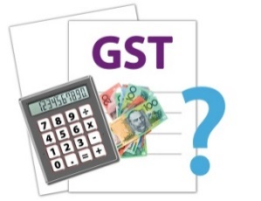 | Most services provided under the NDIS will not include GST. However, GST will apply to some services.
 | It is the service provider's responsibility to check whether GST does or does not apply.
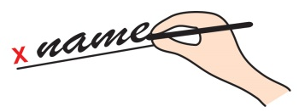 | By signing this Agreement, the service provider says that they have checked whether GST applies.
 | There is more information about this on page 27.
Under tax law, the following sentence must be included in this Agreement:
"A supply of supports under this Service Agreement is a supply of one or more reasonable and necessary supports specified in the statement of supports included, under subsection 33(2) of the National Disability Insurance Scheme Act 2013 (NDIS Act), in the Participant’s NDIS Plan currently in effect under section 37 of the NDIS Act."

Your contact details
Your daytime phone number:
Your evening phone number:
Your mobile number:
Your email address:
Your home address:
The name of someone we can contact if we can't get in touch with you:
Their phone number:

The service provider's contact details
Daytime phone number:
Evening phone number:
Mobile number:
Email address:
Business address:

Signatures
By signing this Agreement, you agree to all of the information included.
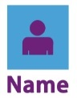 | Participant name:
 | Signature:
 | Date:
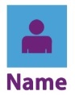 | Service provider name:
 | Signature:
 | Date:

Additional information for service providers
This Guide to Service Agreements has been designed as a tool for you to use with participants in the National Disability Insurance Scheme (NDIS).
It is written in an easy-to-read way, with pictures so that you can explain the main ideas. It also outlines your responsibilities as a service provider in a clear and simple way.

About the Goods and Services Tax (GST)
Most supports provided under the NDIS will be GST-free. However, it is important for service providers to note that you will need to charge GST for some types of support.
You need to check each Service Agreement on a case-by-case basis to make sure you are complying with the law.
The main law that applies is A New Tax System (Goods and Services Tax) Act 1999. Further information about the NDIS and GST can be accessed on the Australian Taxation Office website.
In signing the Service Agreement, you state that you have checked the GST status of the supports.

Other useful tools
There are a range of useful tools to help you when working with participants. Many of these were developed as part of the Practical Design Fund. You can find these on the NDIS website at www.ndis.gov.au/people-disability/practical-design-fund

Checklist for Service Agreements
I know who is making the Agreement.
This might be me and my service provider, or it might be my trusted person and my service provider.
I know what supports to include.
I know what is expected of me.
I know what is expected of my service provider.
I know how the supports will be paid for.
I know what to do if I want to make changes.
I know what to do if I want to end the Agreement.
I know what to do if I have a problem and I know who to contact.
I have written my Service Agreement, or I have worked with my provider to write the Agreement.
I have signed the Agreement.
I have attached my NDIS Plan to the Agreement if I want to.
I have kept a copy of the Agreement for my records.

Word list
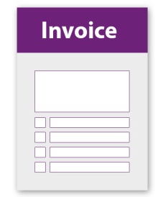 | Invoice  A bill. It explains how much supports costs and when the payment is due.
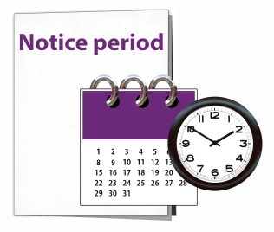 | Notice period  A period of time before a Service Agreement ends. This may be 1 month or more.
Participant
A person with disability who is using the NDIS.
Plan Management Provider
A person or organisation who helps to manage the funding.
Plan Nominee
A family member, carer, friend or other person. If the NDIA says it’s ok, this person can manage your NDIS funding and support you to make other decisions.
Responsibilities
The things that are expected of you or the service provider.
Service provider
The person or organisation that provides you with supports.

Where can I get more information?
If you want more information about Service Agreements you can contact us:
1800 800 110
www.ndis.gov.au

This Easy English document was created by the Information Access Group using PhotoSymbols, stock photography and custom images. The images may not be reused without permission. For any enquiries about the images, please visit www.informationaccessgroup.com

